*Online* Library *Management System*

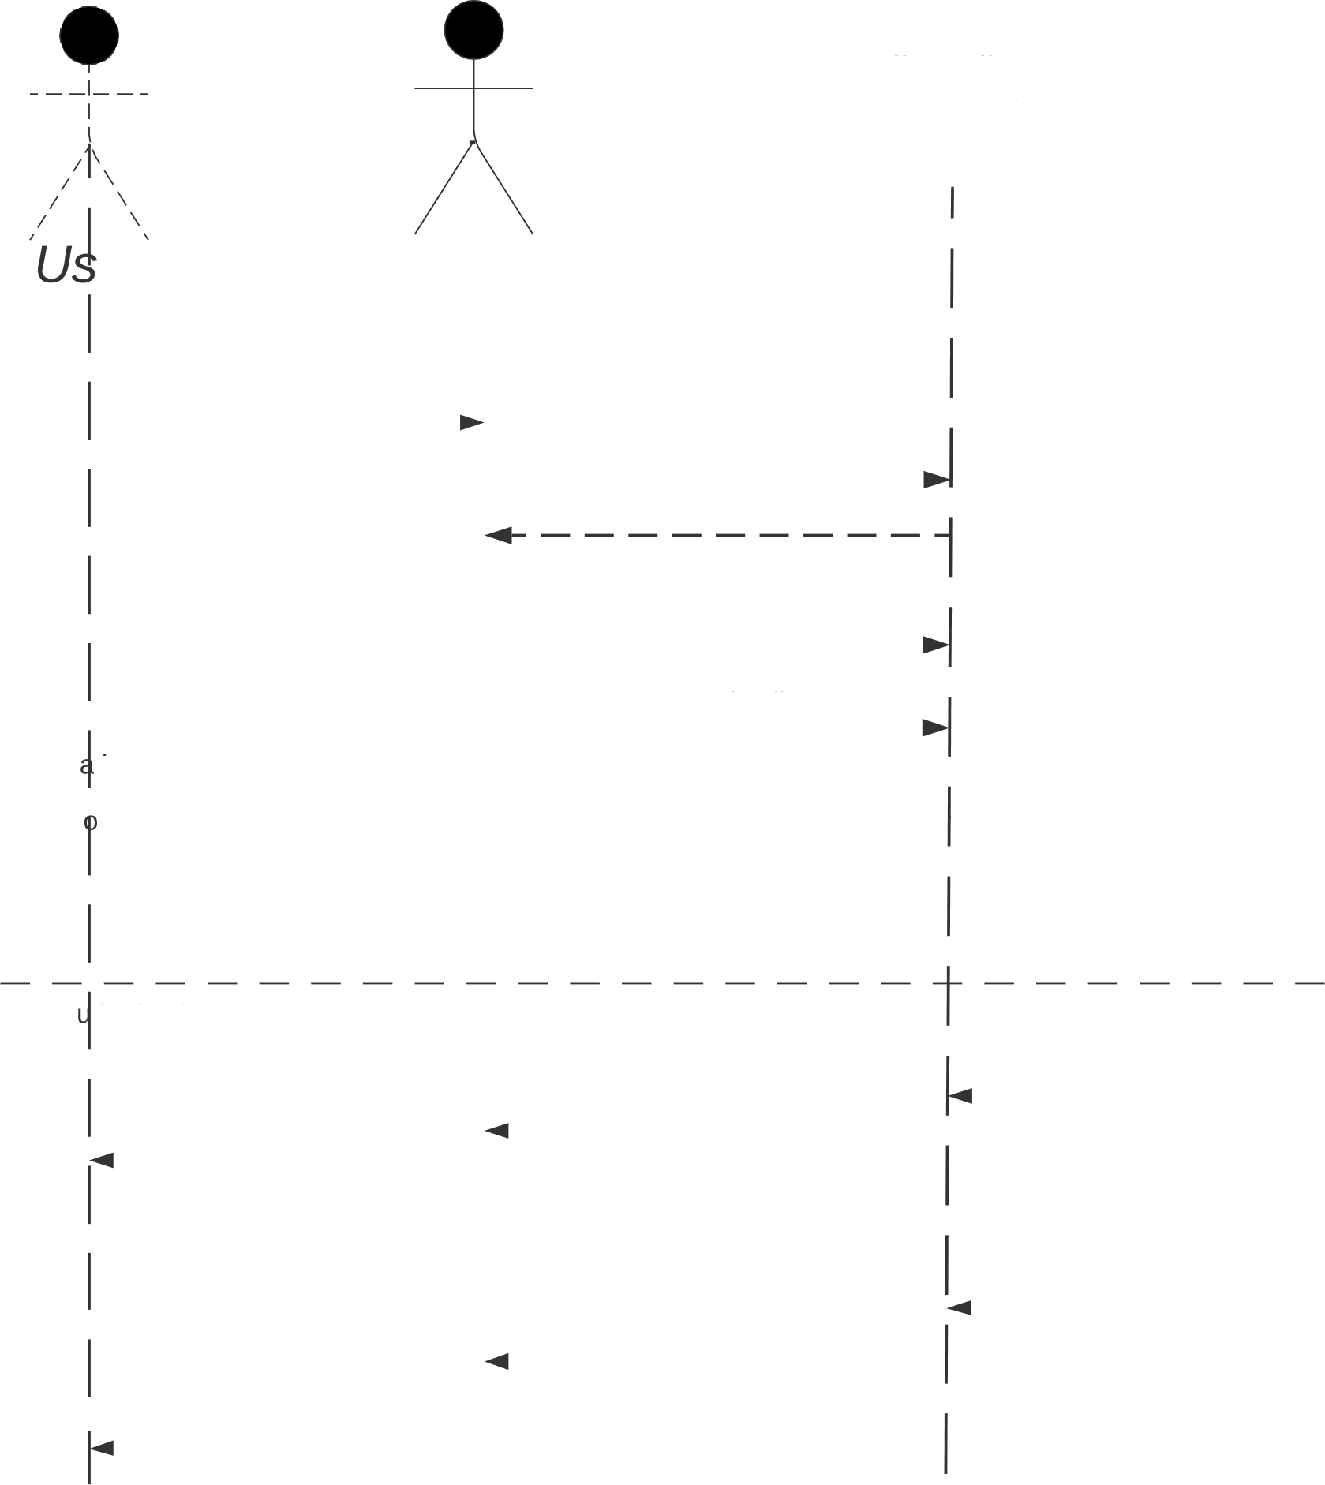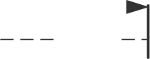

*User* Credenfia/s Data/case

*er Librarian*

*New Library User Account*

I

I.request to create account

1. request to system

3.Acknowledgement

* 1. Account type
  2. User details

Altern tive

Auth rized

* 1. Check Identity
  2. Created user database
  3. Account created

Una thorized

* 1. Sign-up Failed

8.Error creating account

10.Account created

7.Error creating account

9.Account created

11.Email with "Account created" message

I